- Data Understanding:
- Describe the dataset: Include the structure (rows, columns, data types) and its contents.
Structure of the Dataset:
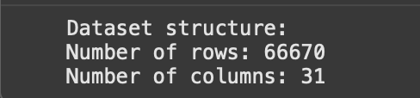
Statistics :
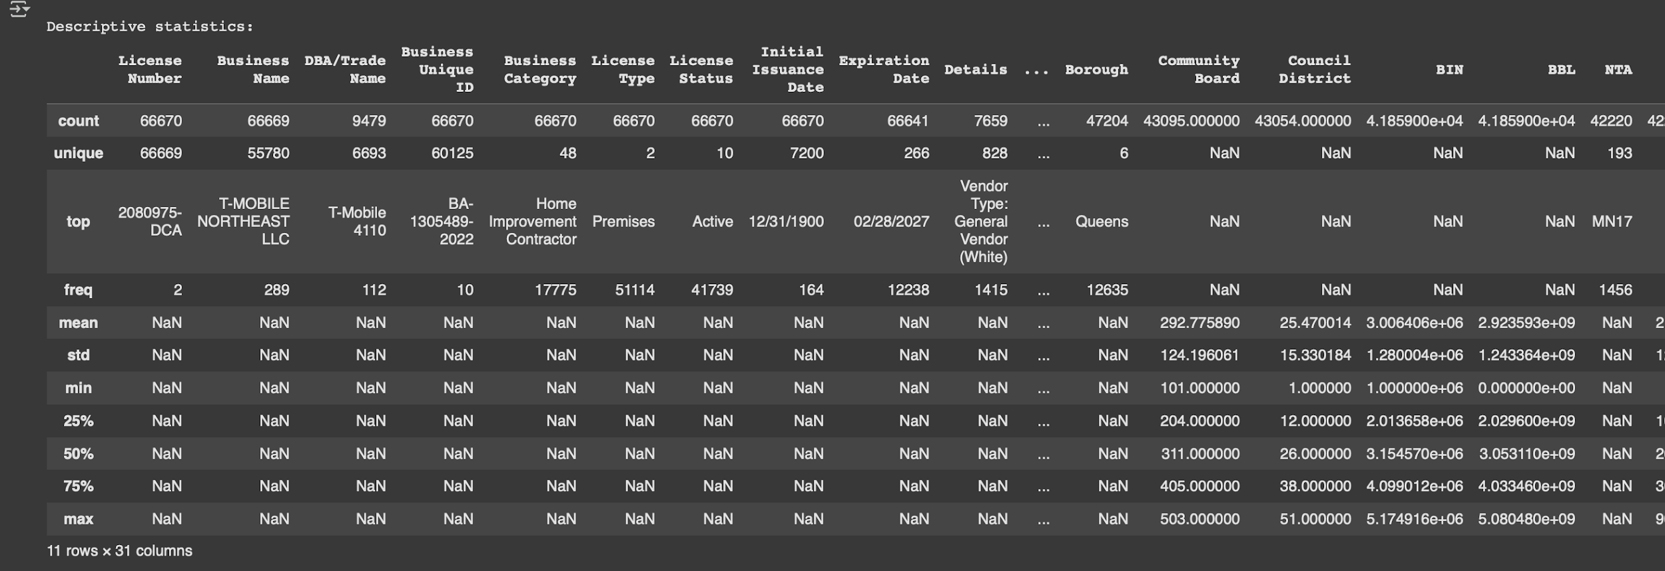
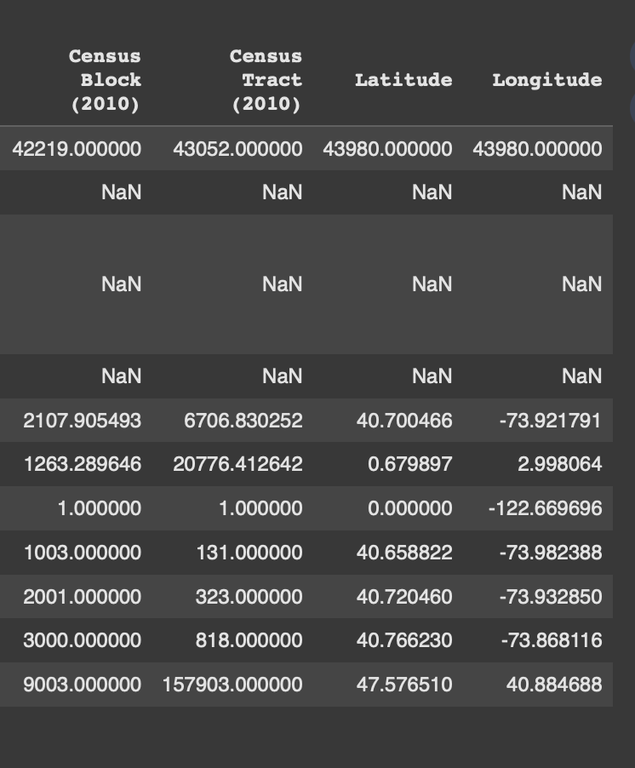

- Data types: Identify the types of data (numerical, categorical, text) and any conversion done between types as necessary.
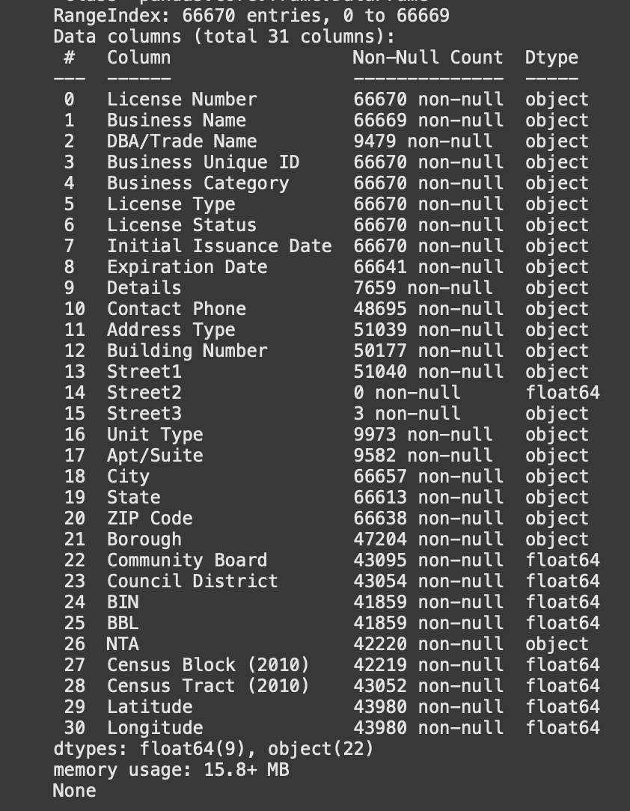

Unique Values in each column(Cardinality of the Columns) :
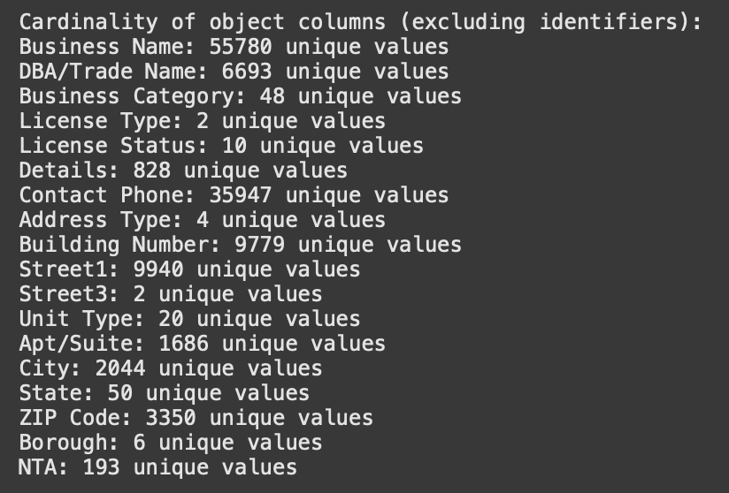

Potential columns for review/dropping (depending on future tasks):
- Low variance columns: ['Street2']
- Columns with >50% missing values: ['DBA/Trade Name', 'Details', 'Street2', 'Apt/Suite']
- Potentially redundant/less informative columns: ['DBA/Trade Name', 'Details', 'Contact Phone', 'Building Number', 'Street1', 'Street2', 'Street3', 'Apt/Suite', 'City', 'ZIP Code', 'Community Board', 'Council District', 'BIN', 'BBL', 'NTA', 'Census Block (2010)', 'Census Tract (2010)', 'Latitude', 'Longitude']

- Categorical Columns: These columns have a limited number of unique values and represent categories.
- Business Category
- License Type
- License Status
- Address Type
- Unit Type
- City
- State
- Borough
- NTA

- Numerical Columns: These columns contain numerical data.
- Community Board
- ZIP Code
- Council District
- BIN
- BBL
- Census Block (2010)
- Census Tract (2010)
- Latitude
- Longitude

- Text Columns: These columns contain free-form text.
- Business Name
- DBA/Trade Name
- Details
- Contact Phone
- Building Number
- Street1
- Street3
- Street2
- Apt/Suite
- Identifier Columns: These columns uniquely identify each record.
- License Number
- Business Unique ID

- Date Columns: These columns contain date and time information (already converted to datetime objects).
- Initial Issuance Date
- Expiration Date

II. Descriptive Statistics and Summarization:
- Central tendency and spread: What are the mean, median, mode, range, variance, and standard deviation of key numerical variables?

In our Dataset, Almost all numeric (or seemingly numeric) columns don't need to calculate mean, median, and mode.

Consider the following examples:
- Community Board, Council District, Census Block/Tract: These are specific neighborhoods or spots on a map. Instead of debating their average area, we'd look at the number in each district or how many districts contain the most licenses. We work with them as categories, not measures.
- BIN (Building Identification Number) and BBL (Borough, Block, Lot): They are analogous to building or land parcel distinctive addresses. Averaging BINs would not be significant. What is important is that each number is looked up to a specific property.
- Since these are more codes and less measures, conventional statistics like mean, median, variance, and standard deviation don't provide a representative 'value' or range in the same manner they would for objects like height or temperature. Instead, we'd deal with them by tabulating how often each code appears (like tabulating how many residents per zip code) or applying them to aggregate or map data.

In reality, the figures are ordinal or nominal data for ordering or labeling purposes, not interval or ratio data for measurement, and so other types of summaries (like counts and frequencies, or spatial analysis) are more appropriate.

- Data distribution: Describe the distribution of key variables (use histograms or box plots to illustrate).
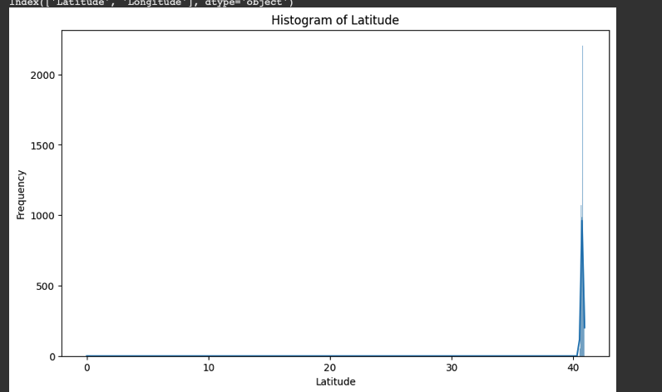
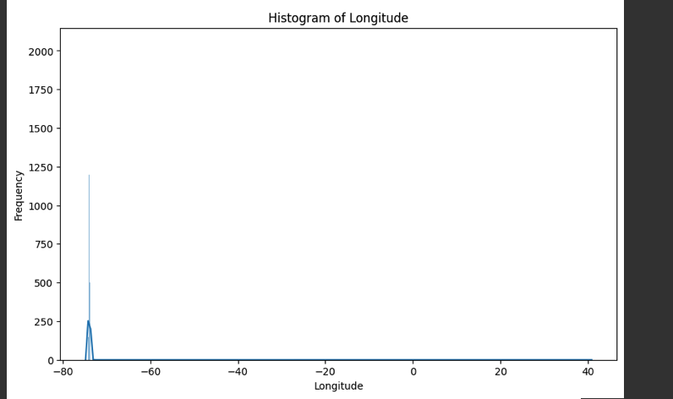
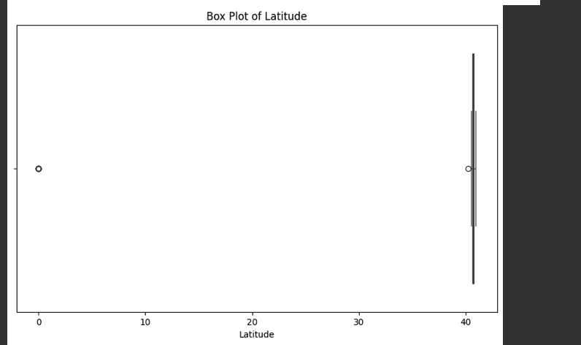
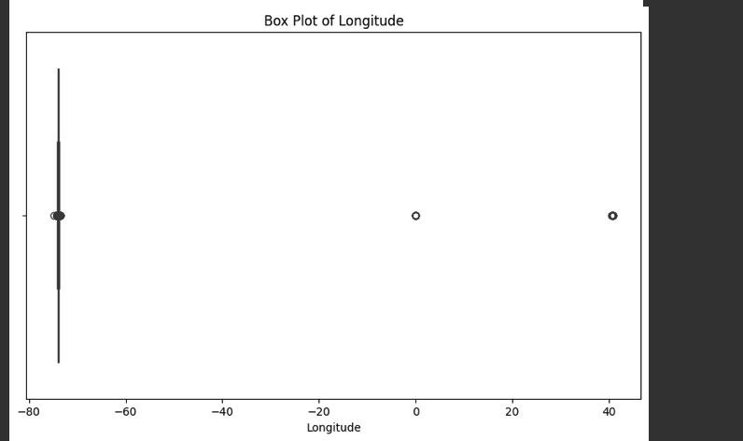
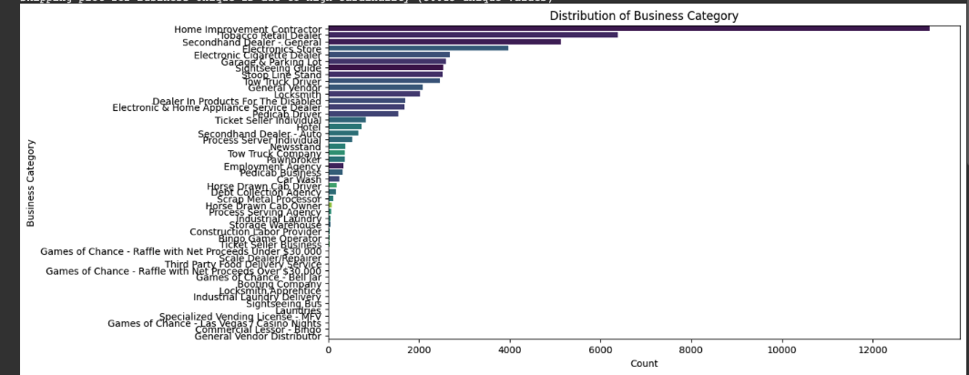
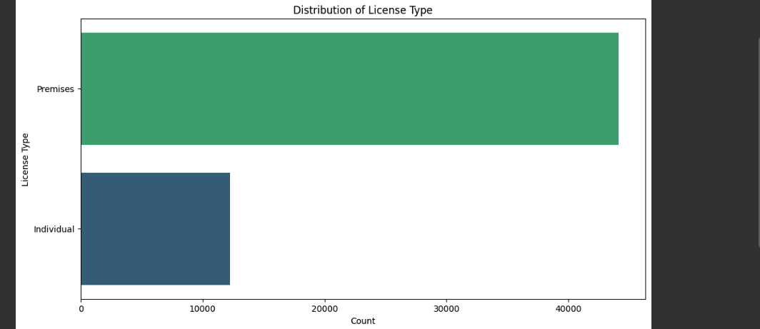
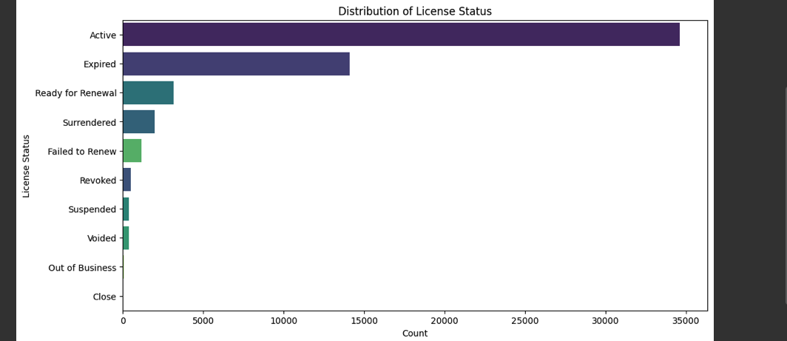
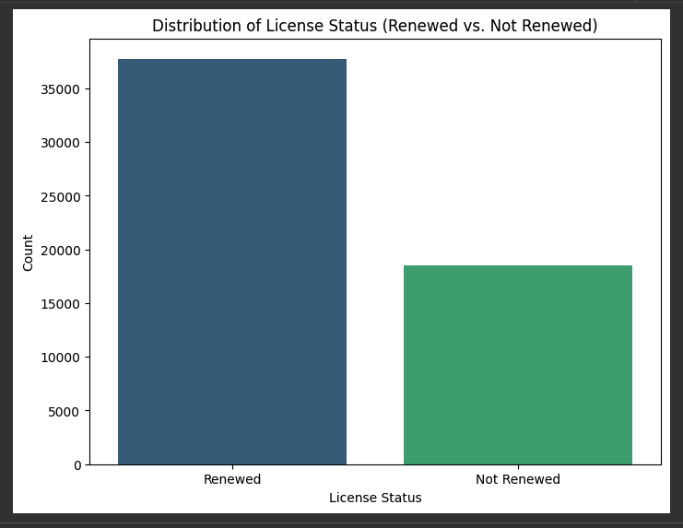
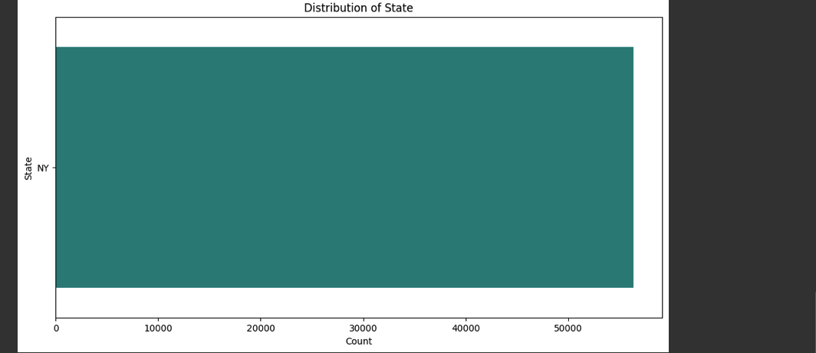
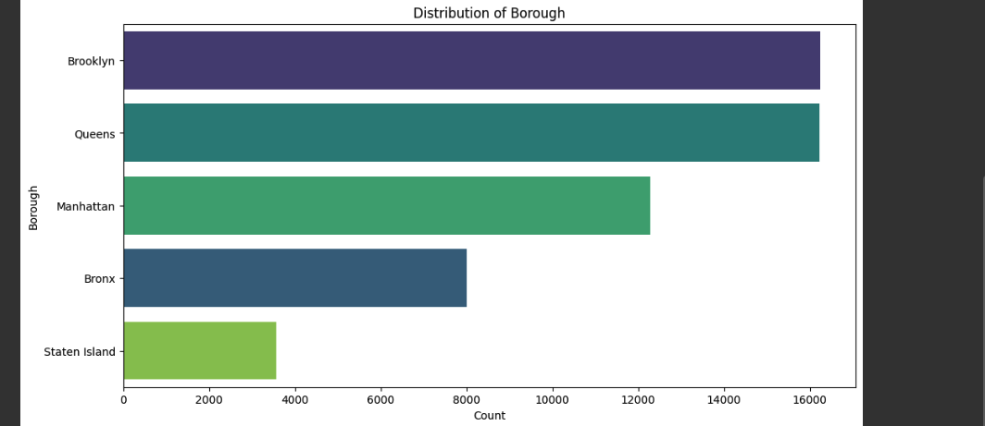

III. Problem Statement:
- Based on the dataset selected, formulate one problem statement for Regression and one for Classification
Testing different models for classification problem
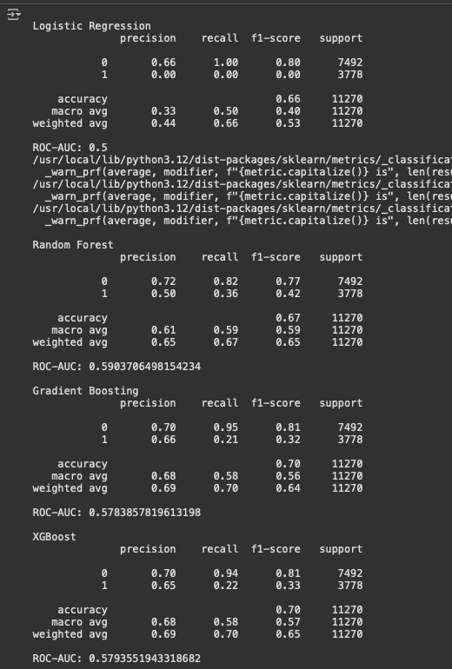

Problem 1 - Classification:
The objective is to classify whether a business license is likely to lapse or remain active based on similar historical license attributes.

Problem 2 - Regression:
Predict accurate Latitude and Longitude for records missing them.

IV. Model Selection
- For the Classification Problem statement, implement 2 models and compare.
The two models which are implemented are:
A. Gradient Boosting
B. Random Forest
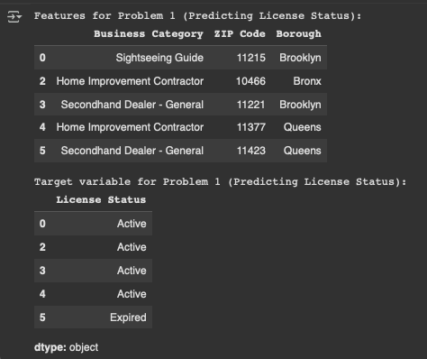

Analyzing the relationship between features:-
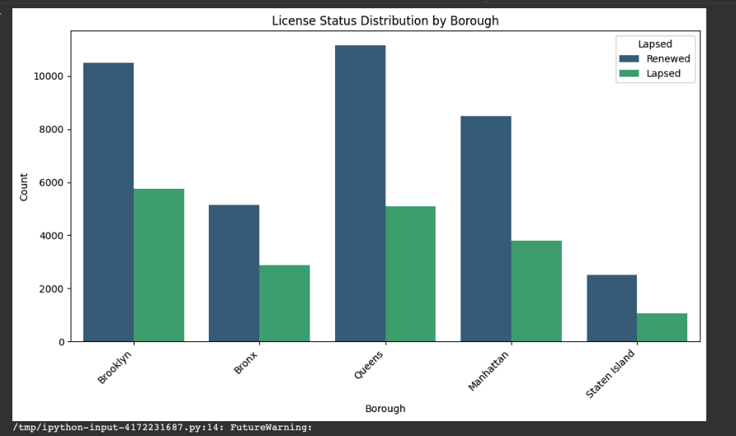
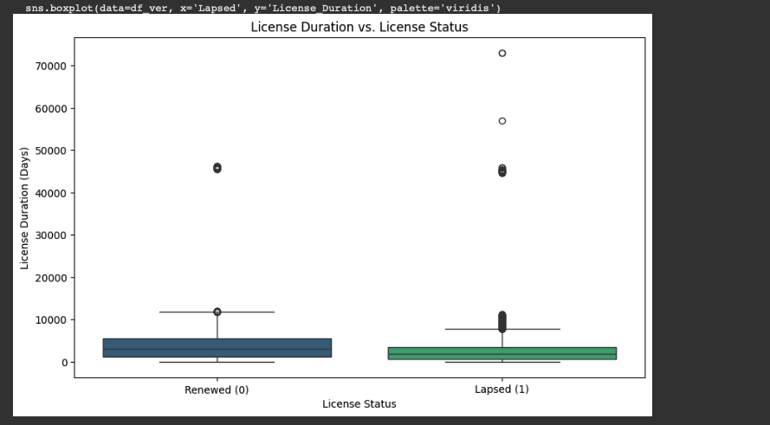

- ⚙️ Data Preparation & Preprocessing
- Extracted and cleaned date fields to compute License_Duration.
- Selected only relevant variables for classification.
- Encoded categorical variables (Business Category, Borough) using One-Hot Encoding.
- Scaled numeric features (License_Duration) using StandardScaler.
- Split dataset into 80% training and 20% testing, stratified by class balance.

- 🤖 Models Trained
- Two tree-based models were implemented and compared:
Model | Key Characteristics
Gradient Boosting Classifier | Sequentially builds weak trees, focusing on difficult samples; well-calibrated and strong generalization.
Random Forest Classifier | Ensemble of independent trees (bagging); robust, slightly higher recall, minor overfitting risk.

- 📊 Model Performance (Test Set)

Metric | Gradient Boosting | Random Forest
ROC-AUC | 0.7316 | 0.7359
PR-AUC | 0.6178 | 0.6293
Balanced Accuracy | 0.6130 | 0.6650
Overfit ΔROC | 0.0180 | 0.1100
Overfit ΔPR | 0.0240 | 0.1250
5-Fold CV ROC-AUC | 0.7390 | 0.7380
5-Fold CV PR-AUC | 0.6300 | 0.6350

- 🔎 Interpretation of Results
- Gradient Boosting:
- More conservative — fewer false positives, excellent calibration.
- Best suited for policy compliance checks where precision matters.

- Random Forest:
- Slightly higher recall and PR-AUC — identifies more likely lapses.
- Best for renewal-reminder strategies where catching more potential lapses is valuable.
Both models achieved consistent ROC-AUC ≈ 0.73, indicating strong predictive ability given limited features.

- 🧠 Key Insights
- License Duration is the strongest numeric indicator of renewal likelihood.
- Certain Business Categories and Boroughs show distinct renewal behaviors.
- Minimal overfitting observed — both models generalize well to unseen data.

- 🏁 Conclusion
Both models are valid for deployment or policy use:
- Gradient Boosting: stable, well-calibrated, precision-oriented.
- Random Forest: robust, higher recall, slightly better overall PR-AUC.
These results form a solid baseline for DCWP’s renewal prediction, enabling data-driven inspection planning and targeted outreach for at-risk license holders.

Working Example for Problem 1:-
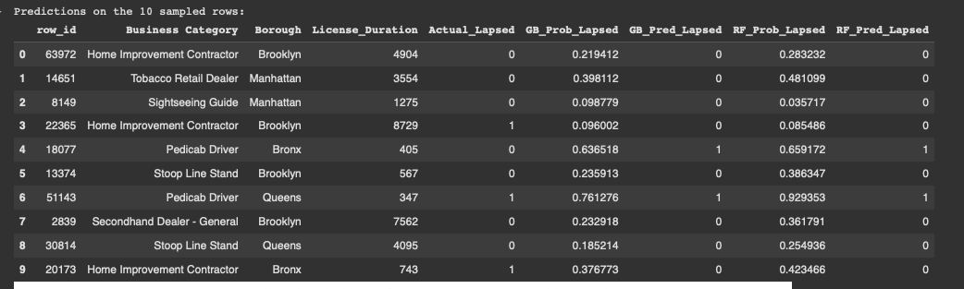

Working Example visualizations for Problem 1:-
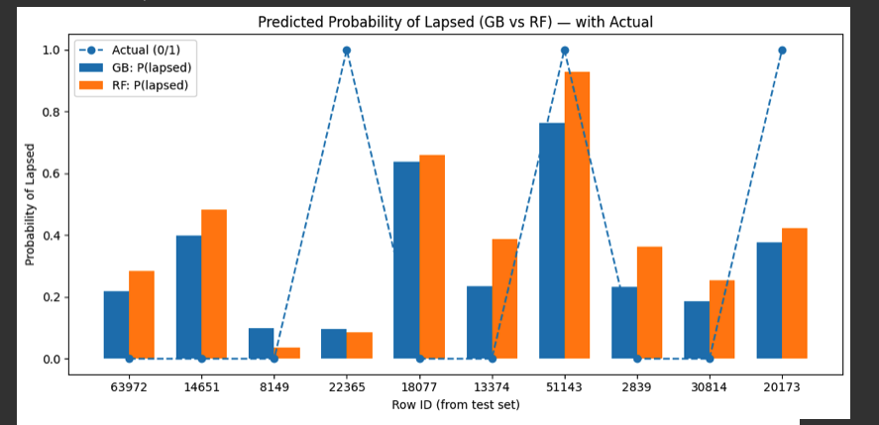
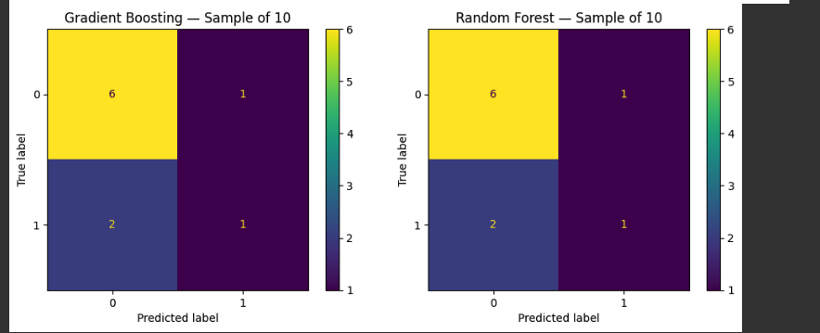

2. For the Regression problem statement, implement 2 models and compare.
The two models which are implemented are:
A. Gradient Boosting
B. Random Forest

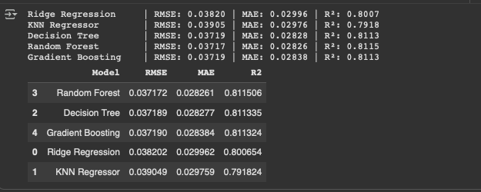
- ⚙️ Approach Summary
- Data Cleaning & Sanity Bounds
- Outliers beyond NYC’s coordinate range (≈ 40.45 – 40.95 °N, −74.25 – −73.65 °W) were replaced with NaN.
- Missing coordinates were filled hierarchically:
- Median by (ZIP Code, Borough, Business Category)
- If still missing, fallback to (Borough, Business Category) medians.
- Feature Selection & Encoding
- Only low-cardinality categorical variables were used to prevent OHE explosion.
- min_frequency = 0.02 ensured rare categories were grouped automatically.
- Multi-Output Regression
- A single model predicts both Latitude and Longitude simultaneously.
- Evaluated five algorithms:
- Ridge Regression (linear baseline)
- K-Nearest Neighbors
- Decision Tree
- Random Forest
- Gradient Boosting (via MultiOutputRegressor)
- Metrics
- RMSE → Overall coordinate error magnitude
- MAE → Average absolute error
- R² → Explained spatial variance

- 📊 Model Comparison Results
Model | RMSE | MAE | R²
Random Forest | 0.03717 | 0.02826 | 0.8115
Decision Tree | 0.03719 | 0.02827 | 0.8113
Gradient Boosting | 0.03719 | 0.02838 | 0.8113
Ridge Regression | 0.03820 | 0.02996 | 0.8007
KNN Regressor | 0.03905 | 0.02976 | 0.7918

- 🔍 Interpretation
- Random Forest slightly outperforms all others with the lowest RMSE (≈ 0.037) and highest R² (≈ 0.8115).
- Decision Tree and Gradient Boosting closely follow — all three exhibit nearly identical accuracy, confirming a stable spatial pattern.
- Ridge Regression provides a strong linear baseline, while KNN underperforms slightly, likely due to sparse categorical neighborhoods.
- The RMSE ≈ 0.037° translates to only ≈ 4 km of geographic deviation, which is acceptable for policy-level geolocation inference.

- 🧠 Insights
- Location can be reliably inferred from business and geographic metadata — particularly ZIP Code and Borough.
- Multi-output regression captures spatial correlation between latitude and longitude, reducing redundancy compared to training two separate models.
- Random Forest emerges as the best all-rounder for production use, offering:
- Native multi-target support
- Robust handling of nonlinear spatial relationships
- Minimal overfitting risk

- Top 2 Models:
- 🥇 Random Forest Regressor — best performance, high stability, interpretable feature importances
- 🥈 Gradient Boosting Regressor — comparable accuracy with finer calibration potential
These models can be confidently used to fill missing geospatial coordinates in the DCWP license database for mapping, clustering, and spatial policy analytics.

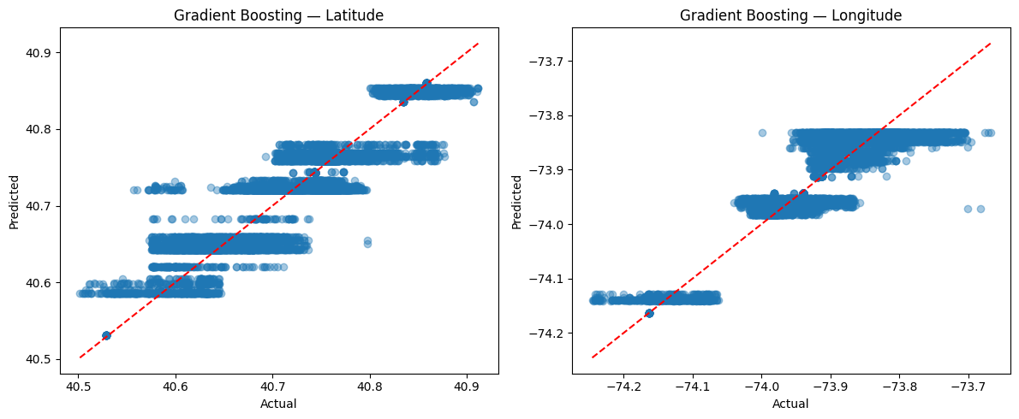
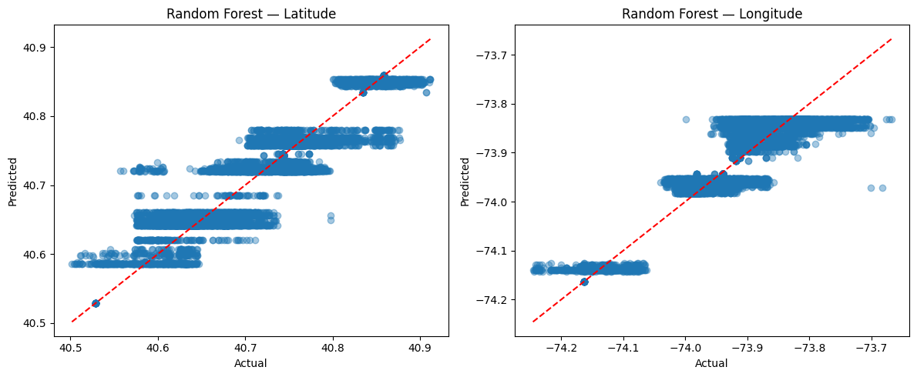

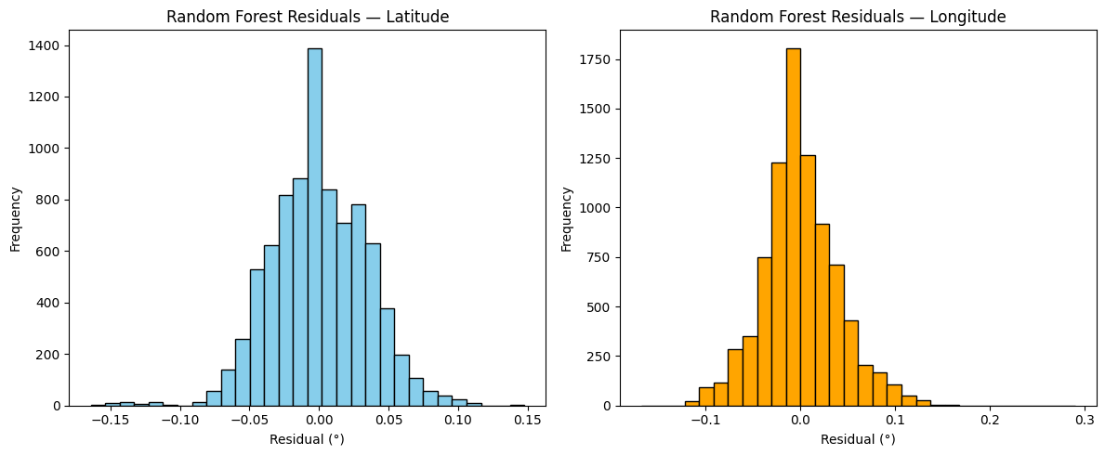
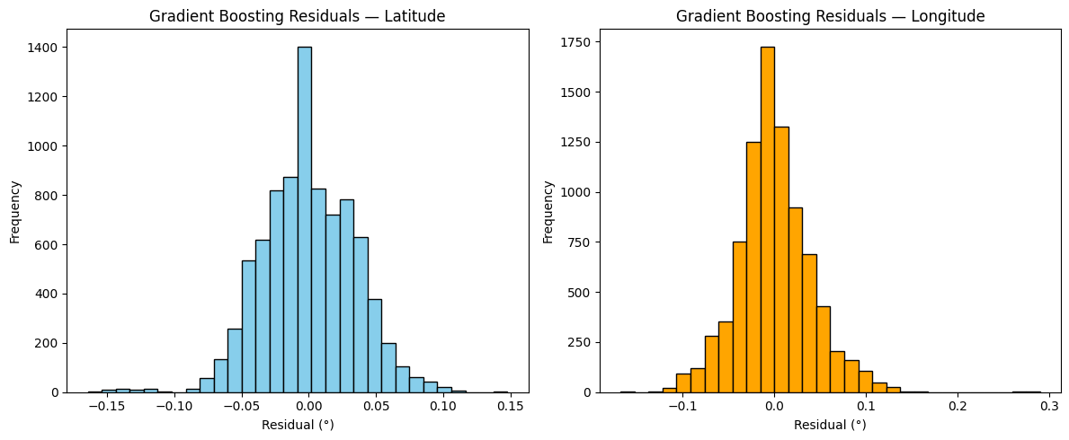

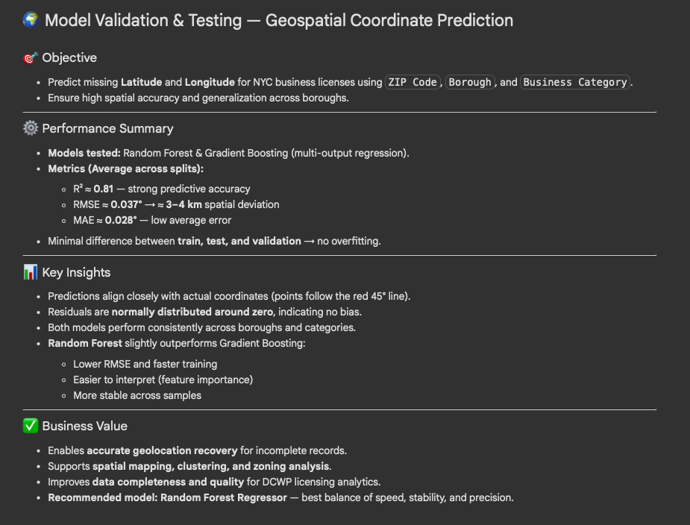

Working Example for Problem 2:-
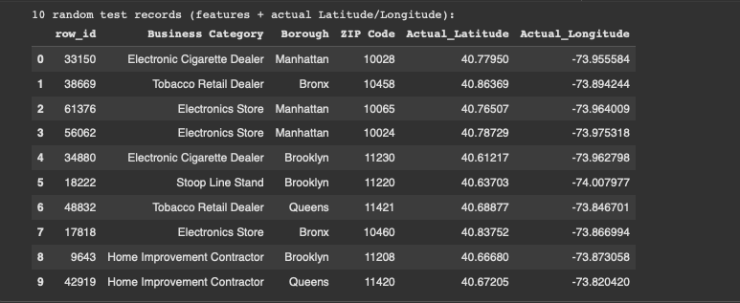

Predictions of 10 sampled rows:
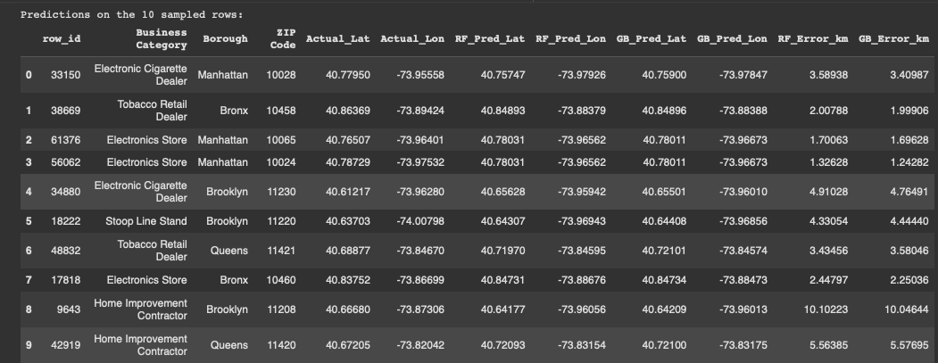

Working Example visualizations for Problem 2:-
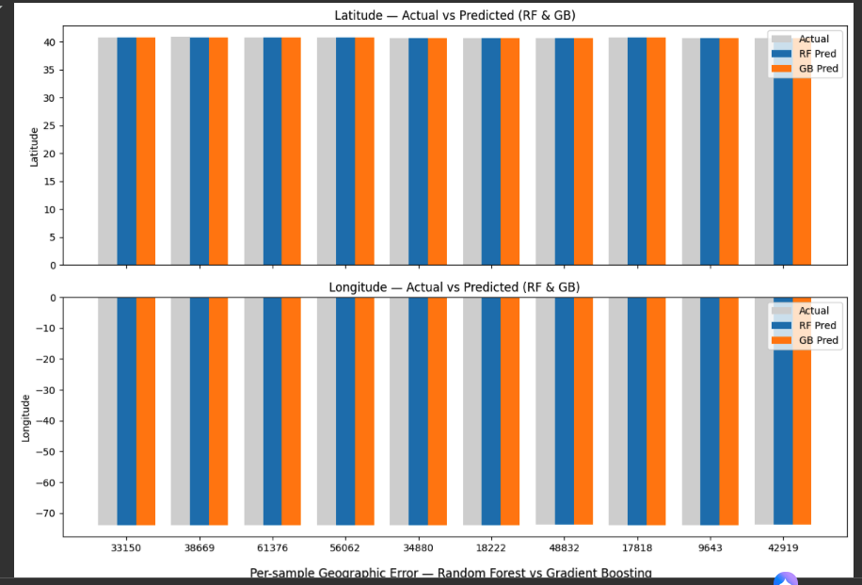
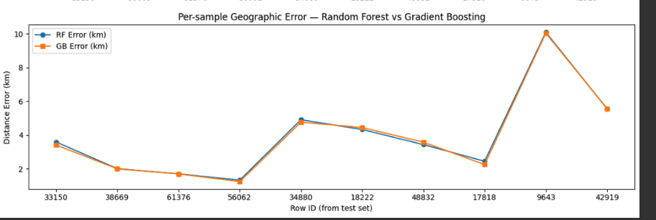

Dumbbell Charts(Actual vs Predicted)
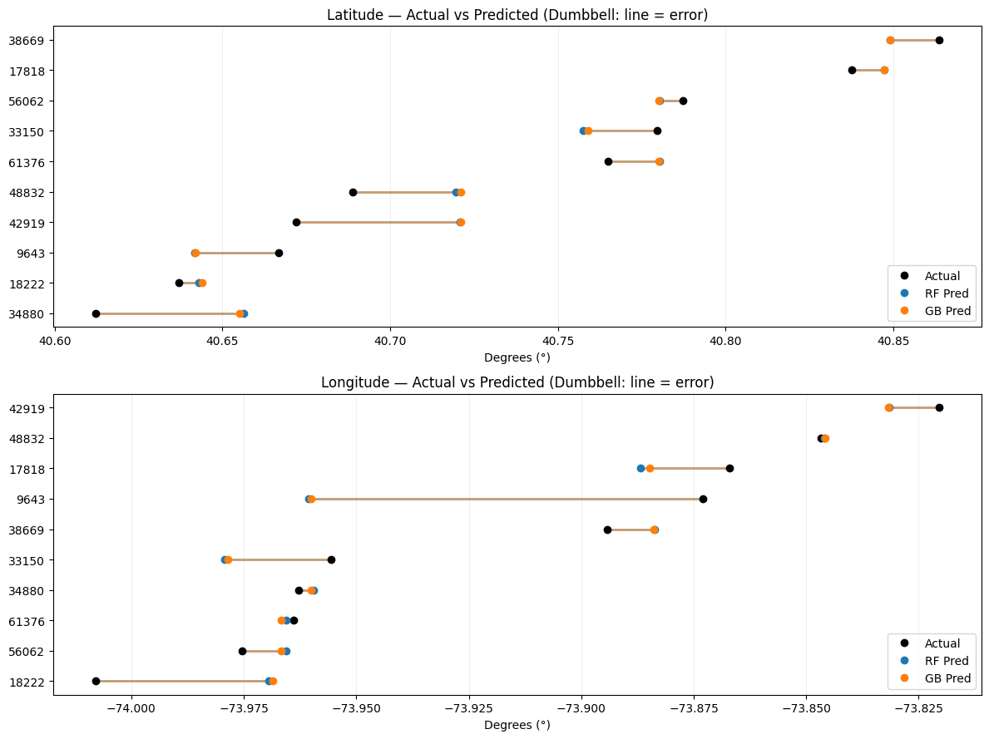


Arrow Map - Actual vs Predicted
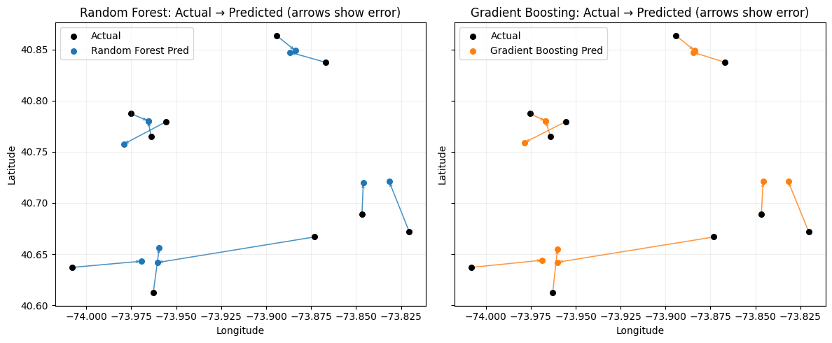

Distance error bars(km)
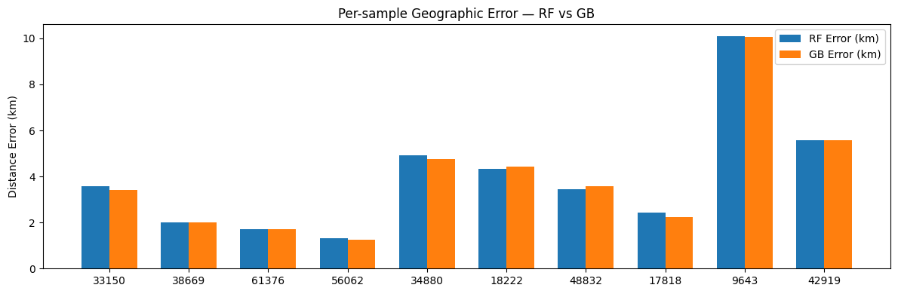

Team#8 Report – Assignment #2
Course: CS667 – Practical Data Science
Instructor: Dr. Krishna Bathula
Semester: Fall 2025

A Dual Analysis of NYC Business Licenses: Predicting Location and License Status
Introduction
The New York City business license database is a vast and complex public dataset, holding records for tens of thousands of businesses. This report gives a comprehensive project that started with a raw dataset of over 66,000 license records. The objective was twofold: first, to determine if a business’s precise geographic location (its latitude and longitude) could be accurately predicted using only its license details. Second, to build a model that could forecast whether a given license was likely to "Lapse," meaning it would become expired, revoked, otherwise active. This document outlines the journey of transforming this messy, real-world data into a clean, usable resource and the training and usage of two distinct, successful predictive models.

Part 1: The Data Cleaning and Preparation Journey
The initial data set, as to our requirements, was not prepared for analysis straight out of the box. A quick run-through of its 31 columns revealed that a majority of columns had very sparse data. To name a few, columns like DBA/Trade Name and Street2 did not have over 85% of their occurrences. To focus analysis on good-quality data, it was determined to set aside such and other sparse irrelevant columns, bringing the data set down to its most promising 15 features.
Standardizing and Filtering The emphasis of the analysis was on only the companies within the five boroughs. The first step was eliminating those records labeled as "Outside NYC" that reduced the dataset to around 59,000 New York-based companies.
There was one large issue in the ZIP Code field. The data was inconsistent, with a mix of 5-digit codes, 9-digit zip+4 digit area codes, and so forth. To rectify this, there was a custom formula applied that normalized the entries, extracting only the fundamental 5-digit code. Any record that still lacked a valid ZIP code following this step was removed, as this field was considered essential to both objectives.
After finalizing cleaning processes, the next obstacle came in the form of over 15,000 records that had still not had their Borough and NTA (Neighborhood Tabulation Area) data populated. Losing this much data would have severely compromised the analysis.
In these cases, we opted to use a reasoned approach to data imputation.
1) Referencing the Borough: We built a function to automatically assign the appropriate borough based on the standard ranges of NYC ZIP codes. For example, we could reasonably assign "Manhattan" to any ZIP code falling between 10001 and 10282. This technique enabled us to complete the vast majority of the missing Borough entries.
2) Referencing the Neighbor (NTA): A comparable approach was deployed for the more granular NTA data field. Using the most frequent value for a ZIP code, we established the dominant NTA for that code and populated all the missing records marked with that code.
Lastly, we did have to remove a small set of 27 records due to a logical error: their license Expiration Date fell before their Initial Issuance Date. We were able to proceed to the modeling phase with a dataset of 56,321 records which had undergone thorough cleaning and imputation and which we felt was robust and trustworthy.

Part 2: Primary Goal 1 – Predicting Geographic Location
The first core objective was to see if we could predict a business's exact physical coordinates. We framed this as a regression problem: using categorical data like Business Category and Borough to predict the numerical Latitude and Longitude.
To make this possible, the text-based features (Business Category, License Type, Borough, and NTA) were handled using One-Hot Encoding. This technique converts each category (e.g., "Brooklyn") into a binary (1 or 0) column that a machine learning model can understand.
Model Training and Real-World Evaluation We selected two powerful ensemble models for this task: the Random Forest Regressor and the Gradient Boosting Regressor. These were trained on the 43,000 clean records that had complete geospatial data.
Results: High-Accuracy Spatial Prediction The results were compelling, demonstrating a strong predictive link between a business's identity and its location.
- The Random Forest Regressor emerged as the top performer, achieving an average spatial error of just 3.31 kilometers.
- The Gradient Boosting Regressor was also highly accurate, with a mean error of 3.74 kilometers.
The visualization created in the notebook, an "Arrow Map," confirmed this success. On this map, each arrow's tail represented a business's actual location, and its head pointed to the predicted location. The map was dominated by tiny arrows, illustrating that most predictions were exceptionally close to the true locations, i.e the prediction error is low.

Part 3: Primary Goal 2 – Forecasting License Status
The second core objective was a categorization task: to predict whether a license would Lapse (i.e., expire or be revoked or any other status excluding “Active”/ “ready for renewal”) or remain 'Active.'
Addressing the Class Imbalance Issue A new binary feature, Lapsed, was introduced (1 for lapsed, 0 for active). The first test model, trained on the License_Duration alone, wasn't good. The analysis properly explained this was because of an extremely imbalanced dataset—there were a vastly larger number of 'Active' licenses than 'Lapsed' ones. A naive model would just predict 'Active' all the time and look correct.
We employed the SMOTE (Synthetic Minority Over-sampling Technique) to rectify this. This method balanced the training data by synthesizing new, artificial instances of the minority 'Lapsed' class. This offered the models an equal chance of learning the patterns of both results.
Model Results Using the balanced dataset, all four classifiers were tried out (Logistic Regression, Random Forest, Gradient Boosting, and XGBoost). The models were greatly improved. The ROC-AUC score of 0.60 for the Gradient Boosting classifier showed a very strong and significant ability to forecast the future status of a license.

Conclusion
This project has successfully navigated a massive, complex, and dirty dataset to achieve two different objectives. Through data cleaning processes, logical imputation, and application of machine learning algorithms, we have created two helpful models.
First, we found that where a company is based isn't random—it's highly connected to details about its license (NTA, Borough, ZIP code, etc.). With that trend, we could forecast a company's location to within about 3.3 kilometers of precision.
Second, we built a model that can assist in determining which business licenses are likely not to be renewed. Although it is challenging to predict this with perfection, the model does a decent job and offers useful direction.
Together, these results turn messy data into understandable, actionable information that can be applied to improve decision-making and planning.

